MIE1622 Assignment 1 Report

Jun Lin Guan

999476124

* 1. Analyzed Results

Period 1: start date 1/2/2015, end date 2/27/2015

Strategy "Buy and Hold", value begin = $ 1000002.12, value end = $ 1043785.08

Strategy "Equally Weighted Portfolio", value begin = $ 992883.36, value end = $ 1019573.21

Strategy "Minimum Variance Portfolio", value begin = $ 991451.85, value end = $ 1015677.04

Strategy "Maximum Sharpe Ratio Portfolio", value begin = $ 990052.21, value end = $ 1007396.51

Period 2: start date 3/2/2015, end date 4/30/2015

Strategy "Buy and Hold", value begin = $ 1045234.09, value end = $ 1069877.19

Strategy "Equally Weighted Portfolio", value begin = $ 1030194.66, value end = $ 1010661.05

Strategy "Minimum Variance Portfolio", value begin = $ 1022865.69, value end = $ 1013172.92

Strategy "Maximum Sharpe Ratio Portfolio", value begin = $ 1016810.45, value end = $ 1056341.89

Period 3: start date 5/1/2015, end date 6/30/2015

Strategy "Buy and Hold", value begin = $ 1085647.24, value end = $ 1027659.63

Strategy "Equally Weighted Portfolio", value begin = $ 1020651.67, value end = $ 986909.50

Strategy "Minimum Variance Portfolio", value begin = $ 1008309.17, value end = $ 968727.99

Strategy "Maximum Sharpe Ratio Portfolio", value begin = $ 1057590.62, value end = $ 1015519.85

Period 4: start date 7/1/2015, end date 8/31/2015

Strategy "Buy and Hold", value begin = $ 1035245.91, value end = $ 947793.98

Strategy "Equally Weighted Portfolio", value begin = $ 990783.04, value end = $ 933666.96

Strategy "Minimum Variance Portfolio", value begin = $ 971304.29, value end = $ 931493.86

Strategy "Maximum Sharpe Ratio Portfolio", value begin = $ 1011267.35, value end = $ 924556.95

Period 5: start date 9/1/2015, end date 10/30/2015

Strategy "Buy and Hold", value begin = $ 912055.56, value end = $ 1027307.87

Strategy "Equally Weighted Portfolio", value begin = $ 903904.29, value end = $ 1022063.45

Strategy "Minimum Variance Portfolio", value begin = $ 899693.36, value end = $ 940083.01

Strategy "Maximum Sharpe Ratio Portfolio", value begin = $ 879622.38, value end = $ 1100283.72

Period 6: start date 11/2/2015, end date 12/31/2015

Strategy "Buy and Hold", value begin = $ 1039856.20, value end = $ 1003328.46

Strategy "Equally Weighted Portfolio", value begin = $ 1039014.66, value end = $ 1034477.23

Strategy "Minimum Variance Portfolio", value begin = $ 944663.18, value end = $ 959275.21

Strategy "Maximum Sharpe Ratio Portfolio", value begin = $ 1103296.64, value end = $ 1217132.87

Period 7: start date 1/4/2016, end date 2/29/2016

Strategy "Buy and Hold", value begin = $ 994608.85, value end = $ 970570.87

Strategy "Equally Weighted Portfolio", value begin = $ 1014128.12, value end = $ 953762.47

Strategy "Minimum Variance Portfolio", value begin = $ 948431.61, value end = $ 943262.65

Strategy "Maximum Sharpe Ratio Portfolio", value begin = $ 1176023.60, value end = $ 1008002.25

Period 8: start date 3/1/2016, end date 4/29/2016

Strategy "Buy and Hold", value begin = $ 999683.25, value end = $ 975547.52

Strategy "Equally Weighted Portfolio", value begin = $ 981740.32, value end = $ 1051834.39

Strategy "Minimum Variance Portfolio", value begin = $ 954850.37, value end = $ 987601.60

Strategy "Maximum Sharpe Ratio Portfolio", value begin = $ 1031446.11, value end = $ 996419.95

Period 9: start date 5/2/2016, end date 6/30/2016

Strategy "Buy and Hold", value begin = $ 982170.01, value end = $ 1000838.49

Strategy "Equally Weighted Portfolio", value begin = $ 1065155.26, value end = $ 1106891.60

Strategy "Minimum Variance Portfolio", value begin = $ 992115.82, value end = $ 1061305.95

Strategy "Maximum Sharpe Ratio Portfolio", value begin = $ 999411.48, value end = $ 1087119.70

Period 10: start date 7/1/2016, end date 8/31/2016

Strategy "Buy and Hold", value begin = $ 1003605.67, value end = $ 1067751.34

Strategy "Equally Weighted Portfolio", value begin = $ 1117980.31, value end = $ 1223913.88

Strategy "Minimum Variance Portfolio", value begin = $ 1061597.83, value end = $ 1047660.59

Strategy "Maximum Sharpe Ratio Portfolio", value begin = $ 1086446.86, value end = $ 1107800.20

Period 11: start date 9/1/2016, end date 10/31/2016

Strategy "Buy and Hold", value begin = $ 1073361.15, value end = $ 1090939.15

Strategy "Equally Weighted Portfolio", value begin = $ 1225757.40, value end = $ 1224338.34

Strategy "Minimum Variance Portfolio", value begin = $ 1044112.98, value end = $ 1019286.17

Strategy "Maximum Sharpe Ratio Portfolio", value begin = $ 1106494.59, value end = $ 1170427.50

Period 12: start date 11/1/2016, end date 12/30/2016

Strategy "Buy and Hold", value begin = $ 1077523.53, value end = $ 1173675.24

Strategy "Equally Weighted Portfolio", value begin = $ 1210668.15, value end = $ 1348478.94

Strategy "Minimum Variance Portfolio", value begin = $ 1005824.42, value end = $ 1118730.89

Strategy "Maximum Sharpe Ratio Portfolio", value begin = $ 1150380.23, value end = $ 1525285.17

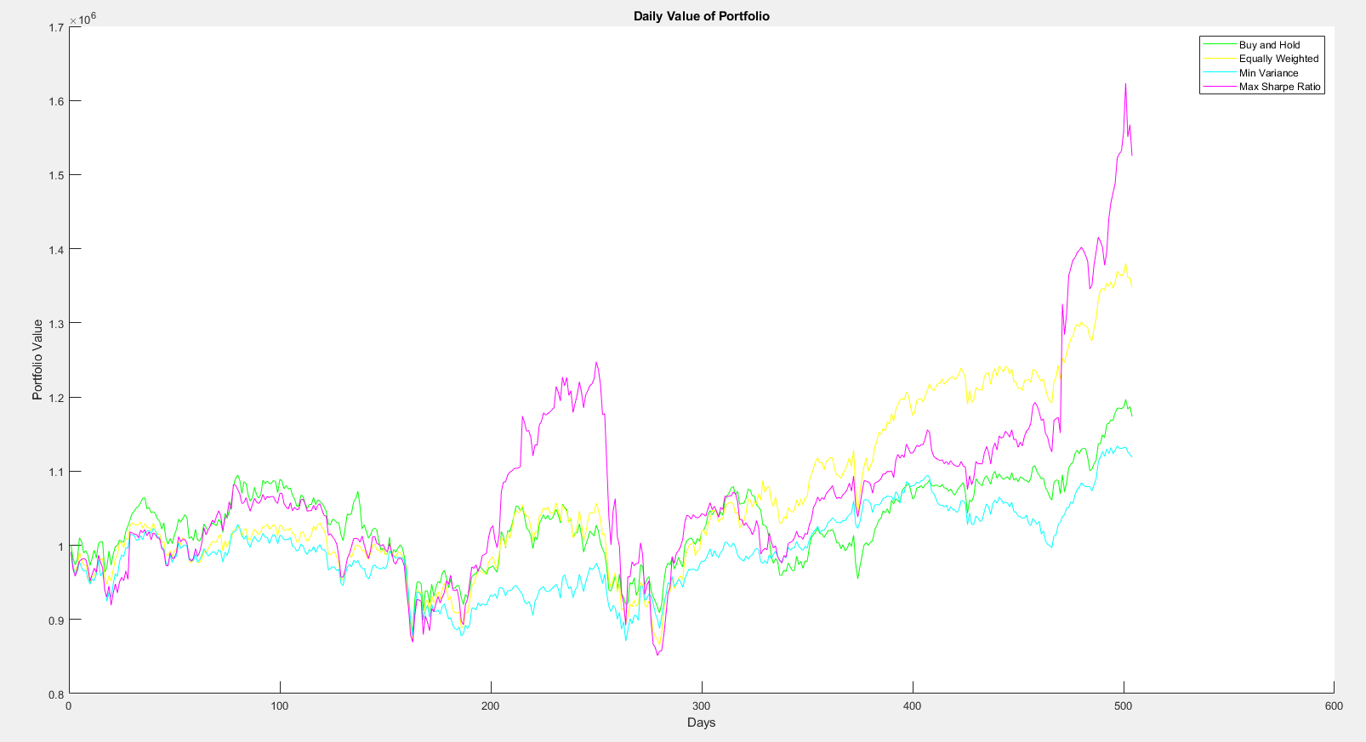

Plot 1: The Daily Value of My Portfolio

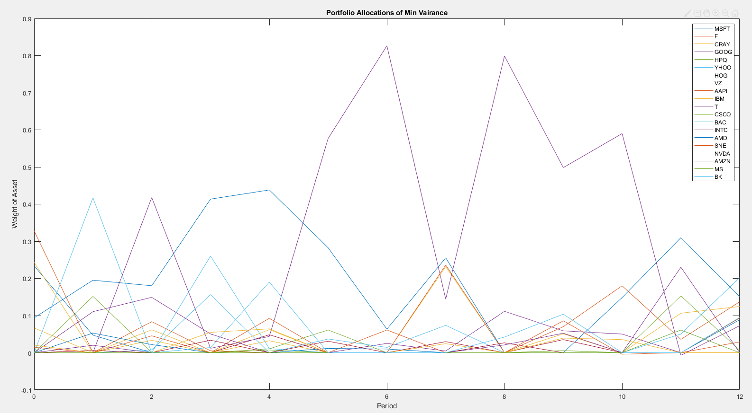

Plot 2: Portfolio Allocation of Minimum Variance

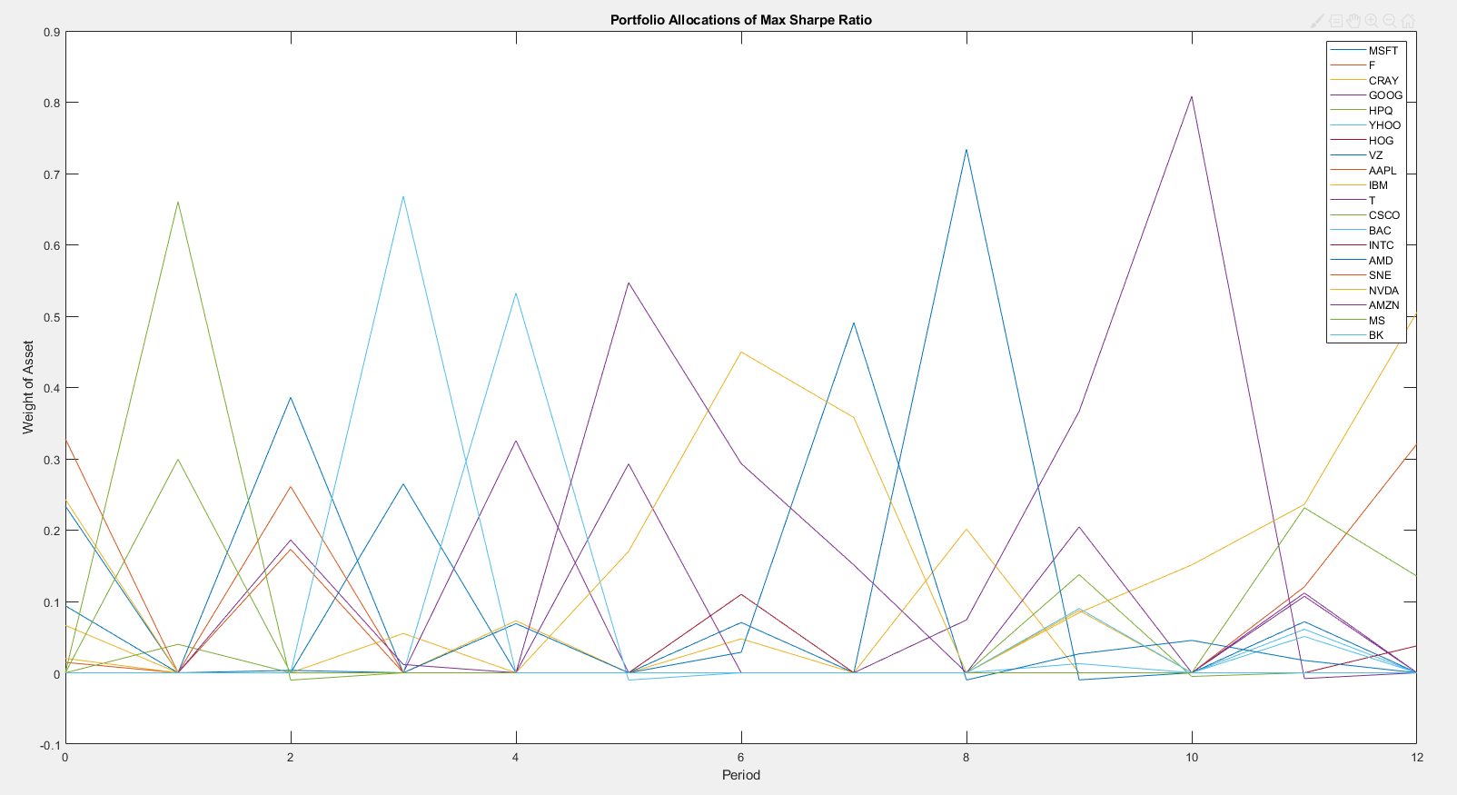

Plot 3: Portfolio Allocation of Maximum Sharpe Ratio

2. Comparison

For the buy and hold strategy, we can see from the daily portfolio plot that it performs the best before day 200, after that it performs roughly the same with equally weighted strategy but got beaten by a lot by maximum Sharpe ratio strategy until day 350. After day 350, the performance of buy and hold strategy has decreased and fell below equally weighted strategy and maximum Sharpe ratio strategy by a lot.

For the minimum variance strategy, the performance is very similar than that of the buy and hold strategy. However, the biggest difference is that from day 180 to day 280, the performance of minimum variance strategy fell greatly by at least 10 percent compared to other strategies.

For the equally weighted strategy, before day 300, it is steadily ranked the 2nd best strategy. After day 300, the portfolio became very profitable and beat other portfolio strategies by a lot until maximum Sharpe ratio strategies caught up after day 500.

For the maximum Sharpe ratio strategy, it is the best overall strategy in these four. With steady performance compared to other strategies and occasionally profit spike around day 200 and day 500. However, is also has the sharpest decrease in profit when other portfolios are not doing good as well.

For me, I would choose the equally weighted strategy, although maximum Sharpe ratio strategy may give the highest profit from the data we collected. You can see that it fluctuates the most as well. I would choose a slightly risky strategy which is the equally weighted strategy.

3. Discussion Questions

(1) “1/n” portfolio at the beginning of period 1 and hold it till the end of period 12.

(2) Minimum variance portfolio at the beginning of period 1 and hold it till the end of period 12.

(3) Maximum Sharpe Ratio at the beginning of period 1 and hold it till the end of period 12.

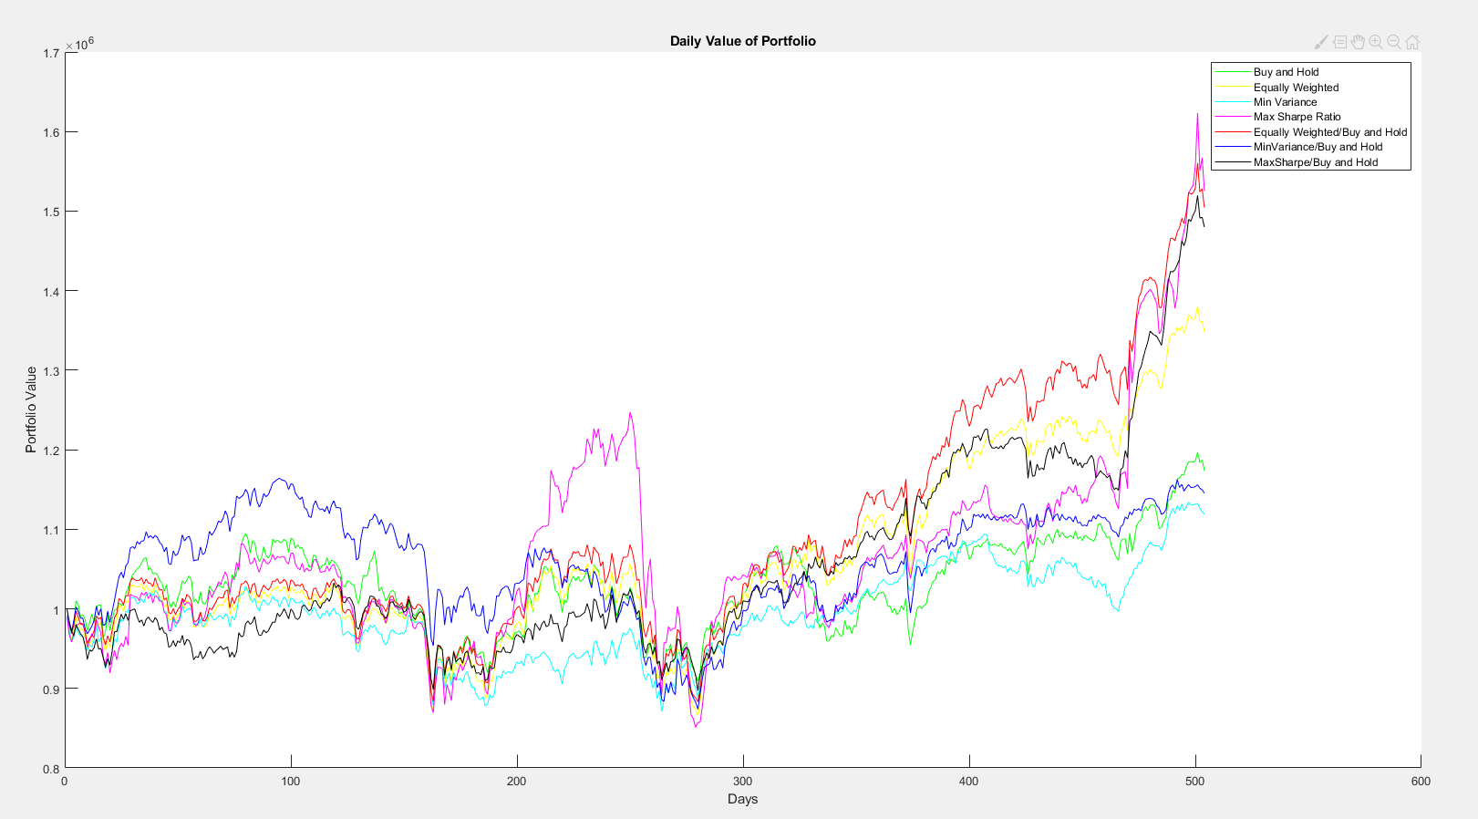

Plot 4. Daily Value of Portfolio with Different Strategies

With the new strategies, it has worked surprisingly well compared to other strategies used earlier. With equally weighted portfolio at the beginning of period 1 and hold it till the end of period 12 performing best out of the other three. The reason behind this might be that the stocks selected has a great growing potential and using the buy and hold strategy after selecting through equally weighted portfolio has reduced the amount of transaction cost needed to rebalance the portfolio. Transaction cost should not be neglected with such high amount of transaction happening.

3.2 Suggestions

With the trading strategies that have been implemented, I believe we can further improve it buy adding constraint on amount of transaction cost and transaction limits. With a big portfolio like this one, it is possible that high amount of transaction would result in market impact and thus result in implicit transaction cost like market impact cost. Also, I would add the option of short selling as another method to further improve profit.